**DAILY ONLINE ACTIVITIES SUMMARY**

|  |  |  |  |  |  |  |  |
| --- | --- | --- | --- | --- | --- | --- | --- |
| **Date:** | **12-06-2020** | | | | **Name:** | **B.A.SOHANKUMAR** | |
| **Sem & Sec** | **4TH SEM A** | | | | **USN:** | **4AL18CS013** | |
| **Online Test Summary** | | | | | | | |
| **Subject** | | **AADALITHA KANNADA** | | | | | |
| **Max. Marks** | | **25** | | **Score** | | **19** | |
| **Certification Course Summary** | | | | | | | |
| **Course** | **DATA SCIENCE WITH PYTHON** | | | | | | |
| **Certificate Provider** | | | **GLA** | **Duration** | | | **11.2 HOURS** |
| **Coding Challenges** | | | | | | | |
| **Problem Statement:1:Write a java program to find the total number of sub arrays which start and end at the same elements.** | | | | | | | |
| **Status: EXECUTED** | | | | | | | |
| **Uploaded the report in Github** | | | | **YES** | | | |
| **If yes Repository name** | | | | **LOCKDOWN CODING** | | | |
| **Uploaded the report in slack** | | | | **YES** | | | |

**ONLINE TEST DETAILS:**

Today there was a test on all 10 chapters of AADALITHA KANNADA (18KAK49). Duration of the test was 25 minutes from 11.30am to 11.55am.Questions were of multiple choice.Score I received is 19/25.

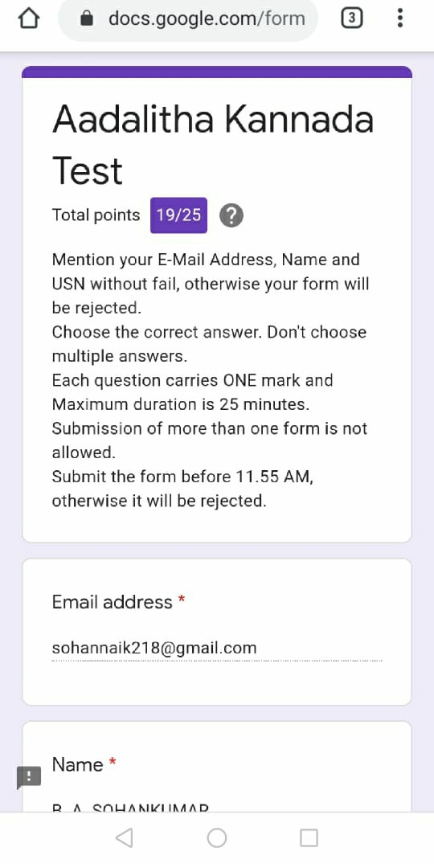

**CERTIFICATION COURSE DETAILS:**

Course:Data science with python.

Today I have opted this new course and this new course has a 11.2 hours of video content and modules.Completed topics today are Introduction to the Course,Basics of Statistics,Descriptive Statistics,Cardio Good Fitness Case Study for Descriptive Statistics,Measures of Central Tendency,Measures of Dispersion,Understanding Distributions & Histograms,Box Plots,Summarizing Data,Pair Plots,Types of Data,Univariate statistical plots and usage.

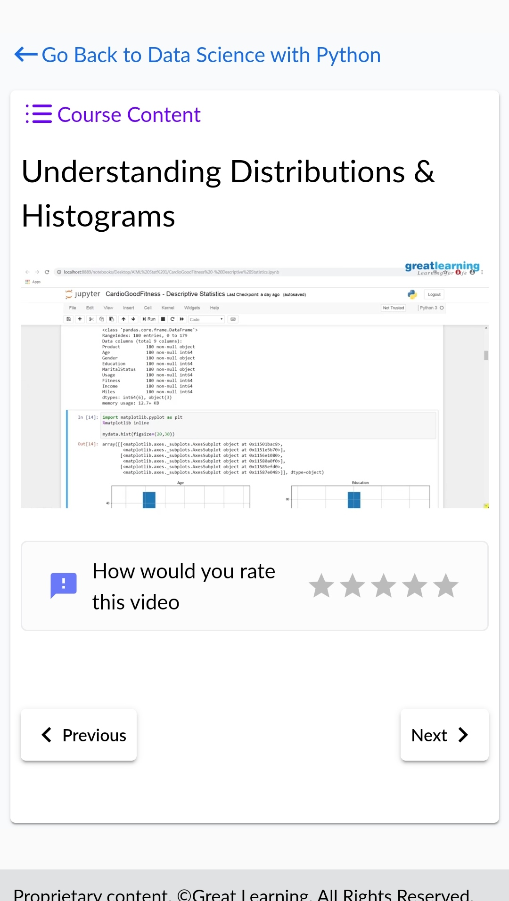 

**CODING CHALLENGES DETAILS:**

1.Write a java program to find the total number of sub arrays which start and end with the same elements.

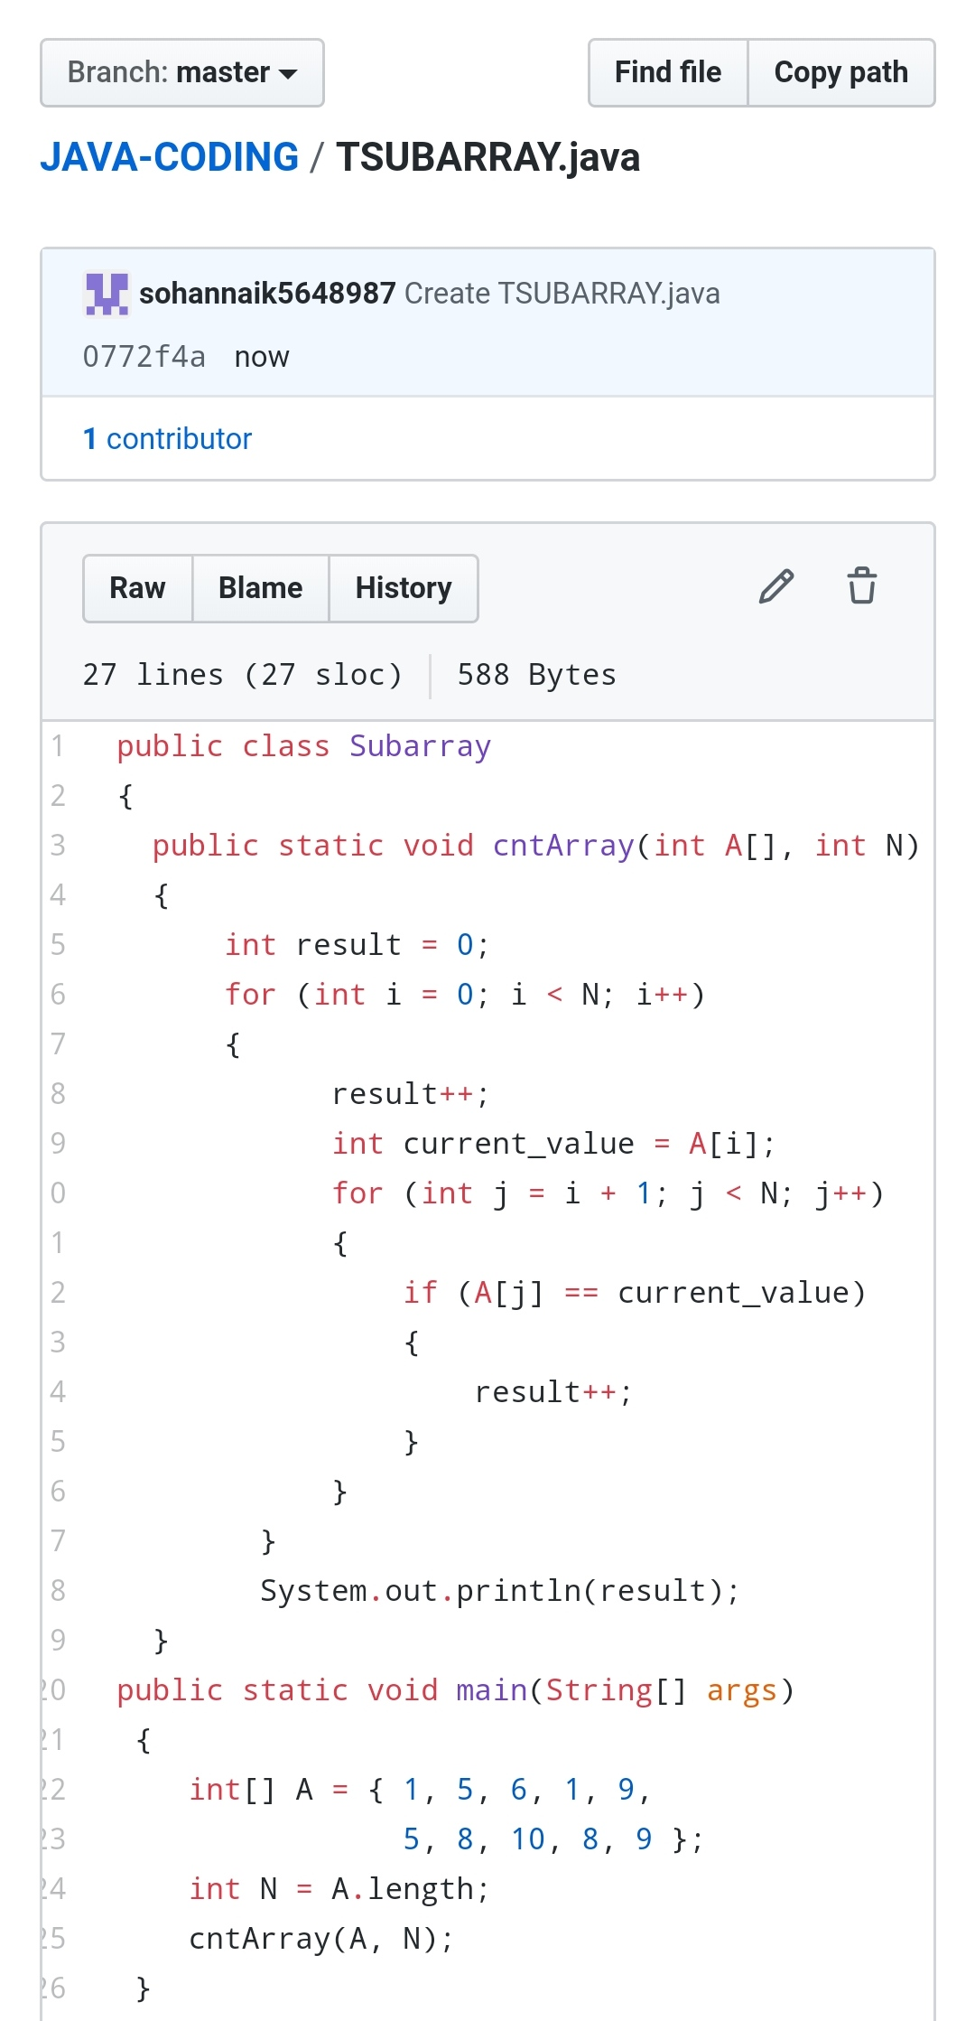

REPOSITORY LINK:https://github.com/sohannaik5648987/JAVA-CODING